The CellCore Biosciences Comprehensive Protocol
Formulated with Carbon Technology
Carbon Technology is a proprietary blend of fulvic acids and polysaccharides that support cellular repair and the body’s natural ability to detoxify. With a low pH, Carbon Technology also helps protect ingredients from being digested by stomach acid, so that they remain intact as they enter the desired location in the body. All of the supplements are formulated with Carbon Technology, with the exception of Para 1, Para 3, and the IS-line.

Note – you can take drainage products and binders all the way through the protocol. Ask your practitioner for guidance.

Phase 1 - Energy and drainage – 30 days (or until full doses)
Prepare your body for a successful detox experience
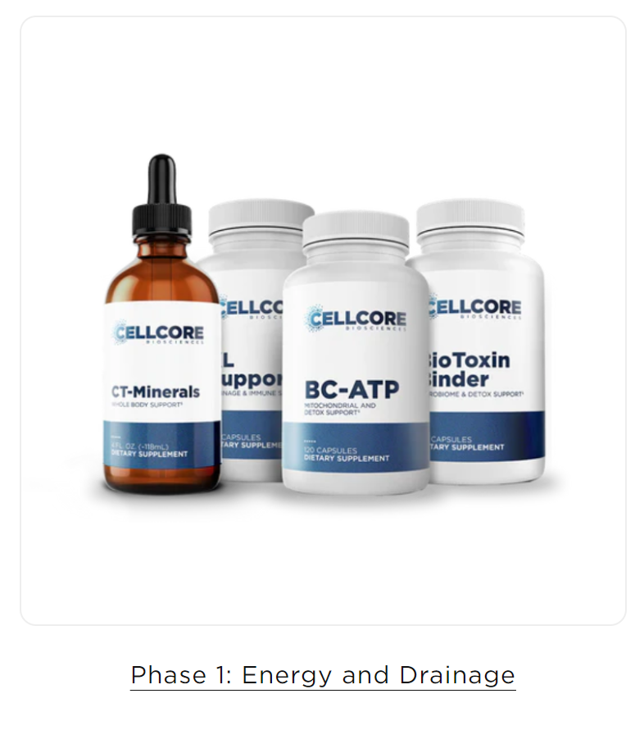
The products in Phase 1 deliver key nutrients for optimizing mitochondrial health and establishing healthy drainage pathways — both of which are essential before promoting periods of detoxification. This also helps minimize unwanted reactions and encourages sustained energy as your patient moves through the protocol.

Add one product at a time (in the order listed) and build to a full dose of each one before adding the next product.
If you get stuck before reaching full dose, add the next product and move on and try to increase it when you are on all of the Phase products.
Stay on Phase 1 a minimum of 30 days on full dose.
Phase 1 consists of BC-ATP, BioToxin Binder, CT-Minerals, and KL Support. If you are not having at least 1 bowel motion per day, or become constipated throughout the protocol, add in Bowel Mover Bowel Mover † – CellCore Biosciences. Start with 1 cap once per day, you can take 2 caps three times a day if needed.
- BioToxin Binder lends increased support to the gut microbiome, which in turn supports healthy digestion and immune health. Especially for fungal, candida and bacteria.
Start with 1/2 cap per day. Work up to 2 caps twice daily.
BioToxin Binder † - Microbiome Gut Supplements - CellCore Biosciences
- CT Minerals, a liquid supplement, provides minerals derived from fulvic acid that enhances mental clarity, nourishes tissues, promotes immunity, and supports cellular repair and detoxification. These naturally occurring minerals are typically easier for the body to digest, absorb, and utilize.
Start with one drop in water. Work up to 10 drops in water twice daily.
CT-Minerals – CellCore Biosciences
- BC-ATP promotes cognitive function and mental clarity. It is CellCore’s most powerful supplement for supporting and optimizing mitochondrial function. When your body has the nutrients it needs to support mitochondria and ATP output, you can experience improved cognitive function, mental clarity and focus, and sustained physical energy. In clinical practice, BC-ATP is generally well-tolerated by sensitive patients and can help improve protocol tolerance.
Start with 1/4 cap per day (morning). Work up to 2 caps twice a day. It can be energising, so some people avoid taking it at night.
BC-ATP – CellCore Biosciences
- KL Support As an integral part of the body’s cleaning and filtering system, healthy kidney and liver function is essential to good health — especially while promoting periods of cleansing. KL Support combines herbs and nutrients traditionally used to support kidney and liver health, including beetroot, collinsonia (stoneroot), gynostemma, marshmallow root, milk thistle seed, NAC, and parsley leaf. Together, these support fat metabolism, hepatic blood flow, and healthy urinary tract and bladder function, while helping the body carry out its natural detoxification processes.
Start with one cap per day. Work up to two caps twice daily.
KL Support † – CellCore Biosciences

Phase 1 | WAKE UP | MORNING | NOON | NIGHT | BEDTIME
BioToxin Binder |  | 2 |  | 2
CT Minerals |  | 10 |  | 10
BC-ATP |  | 2 |  | 2
KL Support |  | 2 |  | 2

Phase 2 - Gut and immune support – 60 days (or until on full doses)
Support your immune system and remove intestinal residue

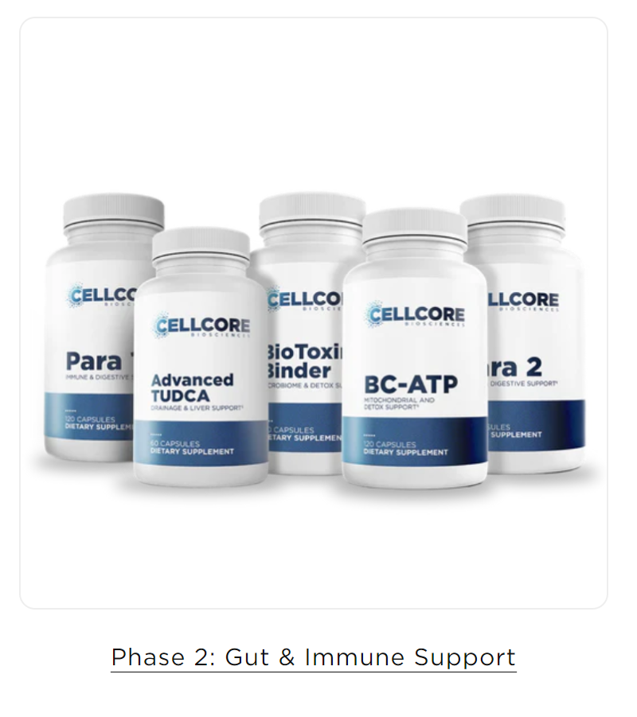
After preparing the body for detoxification in Phase 1, Phase 2 focuses on balancing the gut microbiome, encouraging healthy bile flow, removing occasional intestinal build-up, and optimizing digestive function.
Phase 2 consists of Advanced TUDCA, BC-ATP, BioToxin Binder, Para 1, and Para 2.
Para 1, the flagship gut and immune support product made from 100% pure Mimosa pudica seed, promotes the elimination of waste in the GI tract.
Para 2 steps in to support enhanced digestive function with herbs used traditionally to promote detoxification and gut health.
Advanced TUDCA is introduced in this phase to promote healthy bile flow and support liver health, both of which are essential for optimizing the body’s natural drainage and detoxification processes.

Patients will continue to take Ct Minerals, BC-ATP, and BioToxin Binder to support digestive function, energy levels, mitochondrial function, and immune health.

Add in the order below:
- Para 1 – CellCore’s flagship immune and digestive support supplement, made from 100% pure Mimosa pudica seed.* Naturally gelatinous, Para 1 becomes jelly-like and sticky as it makes its way through the GI tract. This encourages the removal of occasional intestinal buildup, supports the gut microbiome, and promotes the body’s natural ability to detoxify.
Full dose 2 caps per day twice a day on an empty stomach. Wait at least 40 minutes before food and meds. Start with ½ cap once per day.
- Para 2 - formulated with a variety of herbs to support immunity and the gut microbiome, as well as promote the body’s natural ability to detoxify. Amla fruit, clove bud, holarrhena, neem leaf, and vidanga fruit team up to optimize digestion, support bowel regularity, and help maintain a healthy gut bacterial balance. Para 2 is gentle on the system and safe to take at any time for digestive support. Great for parasites.
Works well with Para 1 – take it at the same time 40 min before food. Full dose 2 caps per day twice a day. Start with 1 cap per day
- Advanced TUDCA
Supporting bile production is essential when it comes to promoting the body’s natural ability to detoxify. TUDCA (Tauroursodeoxycholic acid) is a water-soluble bile acid that’s naturally produced by the body and found in liver bile. When taken as a supplement, it helps stimulate the release of bile into the digestive tract. This supports healthy digestion and drainage, the body’s natural detoxification processes, and the health of the liver bile duct system. Advanced TUDCA is particularly supportive for phase III of liver detox, which is the bile movement phase. However, it promotes increased production and quality of bile, so it also supports phase I and II of liver detox.
Note: Many TUDCA supplements are sourced from animal bile. For purity and ethical reasons, Advanced TUDCA is synthetic and produced in the CellCore lab.
Start with ½ capsule once a day and work up to 1 capsule twice a day.

Plus the Phase 1 products you are already taking
- CT Minerals – serving size 10 drops
- BC – ATP – 2 caps twice a day (if it energises you, avoid taking it at night.

Phase 2 | WAKE UP | MORNING | NOON | NIGHT | BEDTIME
Para 1 | 2 |  |  |  | 2
Para 2 | 2 |  |  |  | 2
CT Minerals |  | 10 |  | 10
BC-ATP |  | 2 |  | 2
Advanced TUDCA |  | 1 |  | 1

Phase 3 – Whole Body Immune Support – 60 days (or until at full doses)
Build momentum for a deeper detox

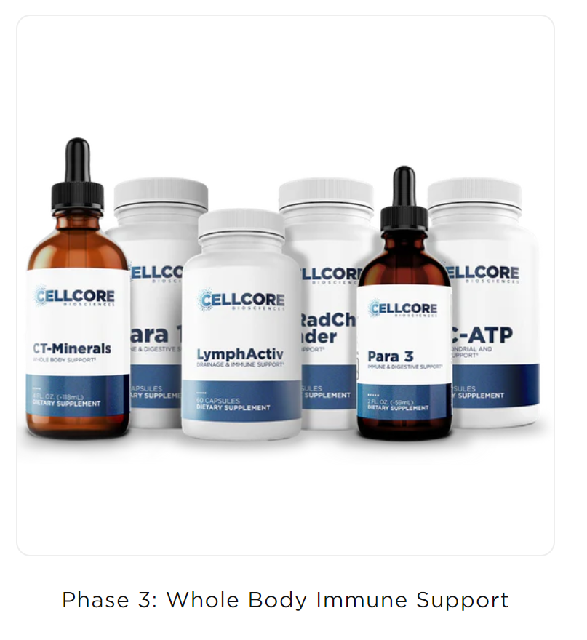

Phase 3 builds momentum for deeper, whole-body cleansing with six products: BC-ATP, CT-Minerals, LymphActiv, Para 1, Para 3, and ViRadChem Binder.
After completing Phase 2, patients will continue to promote healthy drainage pathways, including lymphatic drainage, with LymphActiv. They will also support the removal of occasional intestinal buildup and the body’s natural ability to detoxify by continuing Para 1 and adding Para 3. ViRadChem Binder is introduced to promote systemic detoxification and lessen unwanted reactions.
Continue to take Para 1, BC-ATP, and CT-Minerals to optimize ATP production, energy levels, and immune function.
Add in the order below
- ViRadChem Binder - most well-rounded binder
ViRadChem Binder promotes the body’s natural ability to detoxify while supporting cellular repair. Acai, artichoke leaf, broccoli leaf, and wheatgrass are added to lend increased support to the body’s free radical scavenging systems. The addition of Carbon Technology also supports increased energy production, which is essential for helping the body carry out its routine detoxification functions.ViRadChem Binder is an ideal second-step detox support supplement. Take it after BioToxin Binder, and before Carboxy and HM-ET Binder.
Start on 1/2 capsule a day. Work up to 2 capsules twice a day.
- Para 3
A blend of seven herbs — including clove, black walnut hull, and holy basil — works together to support the body’s natural detoxification processes and gut microbiome.* As one of our most potent detoxification support supplements, Para 3’s liquid tincture format allows the ingredients to be absorbed more rapidly and gives patients complete control over dosing to match their comfort levels.
Note: Because of its potency, Para 3 should be cycled and taken for three weeks on, one week off. The other Para products do not need to be cycled like this.
Start on 1-5 drops. Work up to 2 dropperfuls.
- LymphActiv
Proper lymphatic movement is essential for establishing optimal drainage and supporting the body’s natural detoxification processes. Unlike the cardiovascular system, the lymphatic system doesn’t have its own pump to help drain fluids from tissues. LymphActiv offers a powerful blend of eight herbs to support the body’s natural detoxification processes and lymphatic motion needed to support drainage — including astragalus root, chuchuhuasi bark, rhubarb root, sheep sorrel, slippery elm, and soursop leaf. Together, these botanicals also support healthy adrenal and liver function, immunity, and mental clarity.
Start with 1/2 capsule per day, work up to 2 capsules per day.

Phase 3 | WAKE UP | MORNING | NOON | NIGHT | BEDTIME
Para 1 | 2 |  |  |  | 2
CT Minerals |  | 10 |  | 10
BC-ATP |  | 2 |  | 2
ViRadChem Binder |  | 2 |  | 2
Para 3 |  | 5 - 10 | 5 - 10 | 5 - 10
LymphActiv |  | 1 |  | 1

Phase 4 A – Systemic Detox – 60 days (or until at full doses)
Address lingering, everyday toxins from head-to-toe

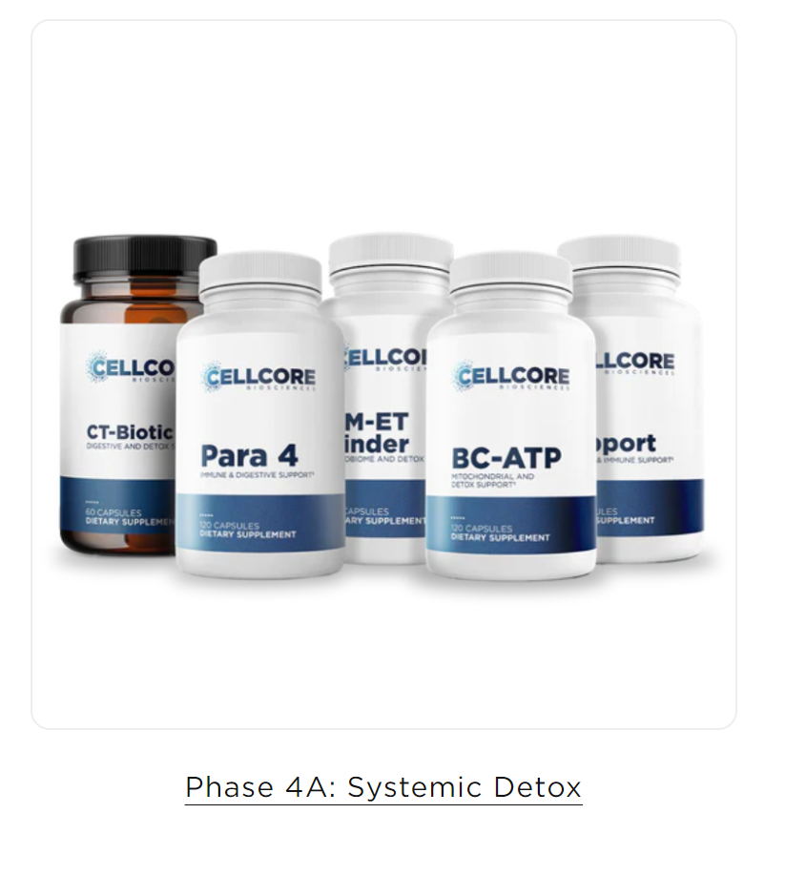
Phase 4A promotes cleansing within and beyond the gut. It consists of BC-ATP, CT-Biotic, HM-ET Binder, KL Support, and Para 4.
Para 4 helps maintain a balanced gut microbiome with herbs used traditionally to support digestive function and immunity, including celery seed, cordyceps, holy basil, and horse tail.
CT-Biotic offers 11 spore-forming and non-spore-forming bacterial strains for increased digestive and detoxification support.* HM-ET Binder steps in to promote the body’s natural ability to detoxify in the cells and tissues, while encouraging cellular repair throughout these processes.
Patients will continue to take BC-ATP and KL Support in this phase to optimize their mitochondrial health and energy levels, as well as support healthy drainage pathways.
Note: After completing Phase 4A, patients will move into Phase 4B, which continues to promote systemic detoxification but without Para 4. This is because Para 4 is a more potent formula and should only be taken for two months at a time.

Phase 4A | WAKE UP | MORNING | NOON | NIGHT | BEDTIME
BC-ATP |  | 2 |  | 2
CT Biotic |  | 1 |  | 1
HM-ET Binder |  | 2 |  | 2
KL Support |  | 2 |  | 2
Para 4 |  | 2 |  | 2

Phase 4 B – Systemic Detox
Ask your practitioner for guidance on how long to stay on Phase 4B
After completing Phase 4A, patients will move into Phase 4B, which continues to promote systemic detoxification but without Para 4. This is because Para 4 is a more potent formula and should only be taken for two months at a time.

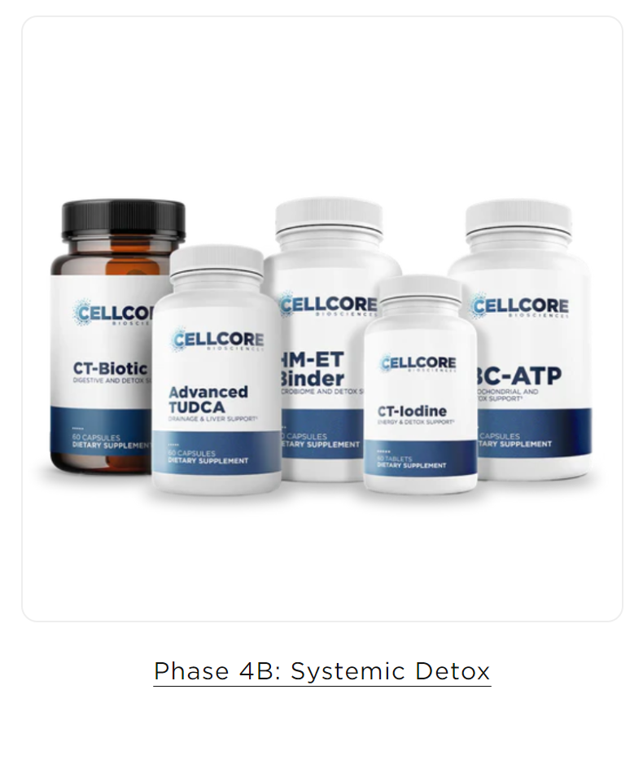
Building on the progress made in Phase 4A, Phase 4B carries on to promote cleansing within and beyond the gut.

Phase 4B consists of Advanced TUDCA, BC-ATP, CT-Biotic, CT-Iodine, and HM-ET Binder. Advanced TUDCA is added back to this phase to continue promoting healthy liver function and bile flow, while CT-Iodine supports hormonal balance, thyroid function, and the body’s natural ability to detoxify.

Patients will continue to take BC-ATP, CT-Biotic, and HM-ET Binder to promote detoxification processes in the gut, cells, and tissues, while also encouraging cellular repair and energy production.

The only new product is CT-Iodine
The body needs iodine and iodide to convert TSH into T3 and T4. These hormones play a key role in optimal thyroid function, as well as cognitive function, digestion, energy production, metabolism, and nervous system support.
CT-Iodine is formulated with optimal ratios of iodine and iodide to support the thyroid gland and entire body. The two forms of this essential mineral are preferentially used by different organs and tissues, which is why we include both for maximum support. The addition of Carbon Technology supports cellular repair and renewal, which promotes the cells’ iodine uptake. Important note: Avoid taking iodine later in the day or evening if you experience trouble falling asleep, as it promotes energy production.
Start with ½ cap in the morning, and work up to 1 cap in the morning.

Phase 4B | WAKE UP | MORNING | NOON | NIGHT | BEDTIME
BC-ATP |  | 2 |  | 2
CT - Biotic |  | 1 |  | 1
HM-ET Binder |  | 2 |  | 2
Advanced TUDCA |  | 1 |  | 1
CT - Iodine |  | 1

Phase 5 Deeper Immune Support – 4 months (or until at full doses)
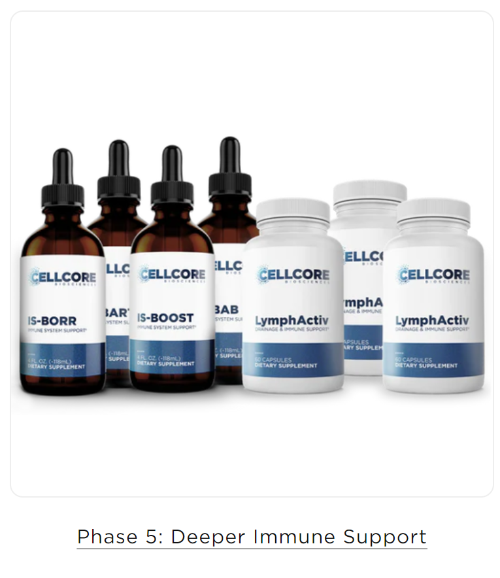
Conquer long-standing challenges and optimize wellness

Phase 5 provides potent blends of herbs in tincture and supplement form, designed to encourage lymphatic drainage, optimize immune system function, promote systemic detoxification, and support the gut microbiome. It consists of IS-BAB, IS-BART, IS-BOOST, IS-BORR, and LymphActiv. Take in the order below, and only add the next item when you are at full dose of the previous one.

LymphActiv
Proper lymphatic movement is essential for establishing optimal drainage and supporting the body’s natural detoxification processes. Unlike the cardiovascular system, the lymphatic system doesn’t have its own pump to help drain fluids from tissues. LymphActiv offers a powerful blend of eight herbs to support the body’s natural detoxification processes and lymphatic motion needed to support drainage — including astragalus root, chuchuhuasi bark, rhubarb root, sheep sorrel, slippery elm, and soursop leaf. Together, these botanicals also support healthy adrenal and liver function, immunity, and mental clarity.
You took this in Phase, which was a few months ago, so start with ½ cap and work up to 1 cap twice a day again if you haven’t been taking it all the way through.

IS-BORR
This team of 24 botanicals — including black walnut hulls, cat’s claw bark, eleuthero root, nettle leaf, turmeric root, white willow bark, wormwood, and several adaptogenic herbs — is designed to encourage a healthy immune response, nurture the immune system, promote energy production, and support the body’s natural detoxification processes.*
The liquid tincture format promotes faster absorption and maximum potency, as well as allows for customized dosing. As a concentrated tincture, IS-BORR has higher potency than capsules. For those who are sensitive, it’s recommended to start with a low dose of one drop, gradually working up to the recommended daily dose of 1-2 droppersfull per day. Take at full dose for 30 days then stop this tincture and move on to the next.

IS-BART
Maintain your immune defenses with this tincture of seven adaptogenic herbs and botanicals, including black walnut hulls, cilantro leaf, milk thistle seed, suma root (Brazilian ginseng), and sweet Annie plant (sweet wormwood). Together, these ingredients support the body’s natural immune defenses and detoxification processes, while promoting energy production.
The liquid tincture format promotes faster absorption and maximum potency, as well as allows for customized dosing. As a concentrated tincture, IS-BART has higher potency than capsules. For those who are sensitive, it’s recommended to start with a low dose of one drop, gradually working up to the recommended daily dose of 2 droppersfull per day. Take at full dose for 30 days then stop this tincture and move on to the next.

IS-BAB
This team of 15 botanicals and adaptogenic herbs — including black walnut hulls, devil’s claw root, milk thistle seed, Japanese knotweed, white willow bark, and wormwood — is designed to nurture the immune system, promote energy production, and support the body’s natural detoxification processes. This blend can also help support the integrity of red blood cells in the body, which makes it ideal for maintaining everyday wellness.
The liquid tincture format promotes faster absorption and maximum potency, as well as allows for customized dosing. As a concentrated tincture, IS-BAB has higher potency than capsules. For those who are sensitive, it’s recommended to start with a low dose of one drop, gradually working up to the recommended daily dose of 2 droppersfull per day. Take at full dose for 30 days then stop this tincture and move on to the next.

IS-BOOST
IS-BOOST combines a blend of 14 herbs, including cilantro leaf, dandelion root, licorice root, oregano leaf, pau d’arco bark, and thyme leaf. Together, these herbs support healthy bile flow, immunity, optimal digestive function, and the body’s natural detoxification processes.
The liquid tincture format promotes faster absorption and maximum potency, as well as allows for customized dosing. As a concentrated tincture, IS-BOOST has higher potency than capsules. For those who are sensitive, it’s recommended to start with a low dose of one drop, gradually working up to the recommended daily dose of 2 droppersfull per day. Take at full dose for 30 days.

You can cycle through the immune tinctures again.
The nutrients in this phase optimize immune system function, which gives the body the extra push it needs to overcome obstacles at the root level.
Note: The liquid tincture format of the IS-line promotes faster absorption and maximum potency, as well as allows for customized dosing. As concentrated tinctures, the IS-line has higher potency than capsules. For those who are sensitive, it’s recommended to start with a low dose, gradually working up to the recommended daily dose.

Phase 4B | WAKE UP | MORNING | NOON | NIGHT | BEDTIME
LymphActiv |  | 1 |  | 1
IS-BORR |  | 1-2 |  | 1-2

Phase 4B | WAKE UP | MORNING | NOON | NIGHT | BEDTIME
LymphActiv |  | 1 |  | 1
IS-BART |  | 2 |  | 2

Phase 4B | WAKE UP | MORNING | NOON | NIGHT | BEDTIME
LymphActiv |  | 1 |  | 1
IS-BAB |  | 2 |  | 2

Phase 4B | WAKE UP | MORNING | NOON | NIGHT | BEDTIME
LymphActiv |  | 1 |  | 1
IS-BOOST |  | 2 |  | 2

Helpful resources
Meet Gen - Nourishing Therapies Where you can buy CellCore products in Australia
Microbe Formulas Detox Heroes | Groups | Facebook – guides to help you get the most out of your detox journey.
Detox Center - Microbe Formulas™ - Join this website for free and access valuable resources. Detox learning centre, articles and videos searchable by topic. Live with the Docs weekly webinars available to watch.
Dr. George — Redefining Wellness Center – Dr George Stanton guides patients through the protocol through Zoom calls. $200 USD initial appointment, then $90 USD for follow up appointments.

